Quiz

Lecture 2: Ancient ports and architectures

- Please name three important port cities of the ancient world.

- Why did port cities become influential centers within the realms of antiquity?

- Which system of city planning can be seen in the image? Explain.

- Please name two types of buildings we encountered during the lecture.

- Please indicate the position of the lighthouse in the map.

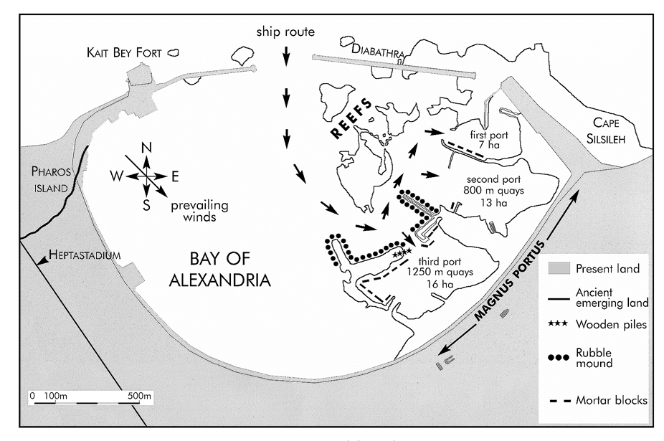

- Why is the port basin of Ostia so far from the coast?

